https://www.wordreference.com/

https://www.deepl.com/translator

https://www.reverso.net/traduzione-testo

Lesson 10

17 February 2022
Watch the clip

Talk About Food and Cooking in English - Spoken English Lesson (13.56)

https://www.youtube.com/watch?v=SlTrn13aez4

2. Adjectives to Describe Food

Scrumptious= delizioso. https://www.wordreference.com/enit/Scrumptious

Translte this words connected with FOOD:
terrible | disgustoso
amazing | Meraviglioso/sorprendente/incredibile
tough | duro
chewy | Stopposa/gommosa
tender | Morbida/tenera
awful | tremenda
scared | impaurito
mushy | Molliccio/poltiglia/molle
crunchy | croccante
crumbly | friabile
bland | insipido
rich | Gustoso/saporito/cibo pesante
junk food | Cibo spazzatura
spicy | Saporito/ piccante
Sour | Acido/aspro/inacidito
Tangy flavour | Sapore acidulo/ pungente
bitter | amaro
sweet | dolce
Flavour ( taste) | Sapore/gusto
Texture | Aspetto, consistenza
Nutrition education | Educazione alimentare
It’s done  https://context.reverso.net/traduzione/inglese-italiano/It%27s+done | È a posto/ si fa/ è fatta
You mean it  https://context.reverso.net/traduzione/inglese-italiano/You+mean+it#dici+sul+serio | Dici sul serio?
You mean it https://context.reverso.net/traduzione/inglese-italiano/You+mean+it | Vuoi dire che
You mean it  https://context.reverso.net/traduzione/inglese-italiano/You+mean+it#fai+sul+serio | Fai sul serio?
You mean it  https://context.reverso.net/traduzione/inglese-italiano/You+mean+it#lo+pensi+davvero | Lo pensi davvero?

How to Talk About Food and Cooking
From (0.54) to (3.50)
Marie: What kind of food do you like?
Oli: I like a bit of everything, really. I grew up in the UK, and you can get food from all over the world there. My mum’s cooking is a combination of different cuisines: a bit of French, a bit of Italian, a bit of Indian, and so on.
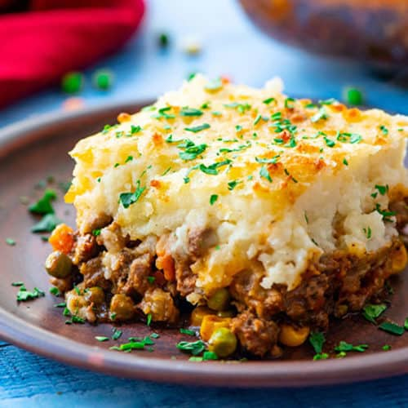
M: What’s British cuisine like? I know about fish and chips, but there must be more…
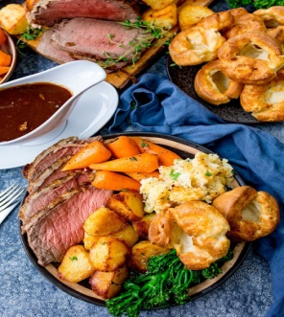
O: There is, but not that much. There are a few famous dishes like shepherd’s pie https://www.thewholesomedish.com/the-best-classic-shepherds-pie/
or Sunday roast, https://www.kitchensanctuary.com/roast-beef-dinner/
but most people eat a mix of things. What about you? What food do you like?
M: I’m half Spanish, so when I was young we ate a lot of Mediterranean food at home. Now, I live in Berlin, and it’s a pretty cosmopolitan place, so you can get all kinds of food, like the UK, I suppose.
O: I’ve never really had much Spanish food. Is it similar to Italian?
M: In some ways, yes. They both use a lot of fresh ingredients, and there’s a lot of seafood, salads, and so on. Pasta isn’t so common in Spanish cooking, though (però). https://www.wordreference.com/enit/though
O: What are some typical Spanish dishes? I’d be interested to try some.
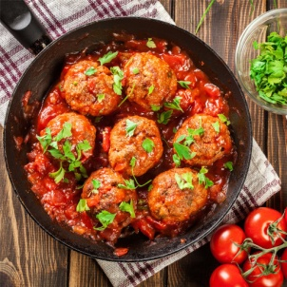
M: I guess paella is quite well-known. My personal favourite is a dish called albondigas, which is meatballs ( olpetta di carne) in a tomato sauce. It’s simple, but so tasty.
O: Sounds good!
Here’s a question: do you know the difference between the words ‘cuisine’, ‘dish’ and ‘meal’?
‘Cuisine’ means the kind of food you find in a specific country or culture. For example, you have Chinese cuisine, French cuisine, local cuisine, and so on. ‘Cuisine’ means something like ‘cooking style’.
You can use the word ‘food’ or ‘cooking’ in the same way. So, you can say ‘Chinese cuisine’, ‘Chinese cooking’ or ‘Chinese food’. The meaning is very close.
A ‘dish’ means something which is cooked or prepared. Usually, a dish is made from different kinds of food.
A ‘meal’ is food eaten at a specific time. Most people eat three meals a day:
breakfast, lunch and dinner.
We often hear English learners make mistakes with these three words, so be careful with them!
In the dialogue, you heard how to talk about different cuisines and dishes which you like.
Look at some questions you heard:
- What kind of food do you like?
- What’s (your country’s) cuisine like?
- What are some typical dishes in your country?
Think about how you could answer these.When you answer these questions, try to be detailed. For example, don’t just say ‘Vietnamese food is delicious.’ Give some more details! Say what kind of dishes are the best, or try to explain why you like it.For example, you could say :
‘Vietnamese food is delicious, because it uses fresh ingredients and it’s a little bit spicy, which I like.’
OK? Pause the video and try to answer the questions now. Could you do it? If not, go back and listen to the dialogue again.
Next, let’s look at how to talk about food you like – or don’t!

2. Adjectives to Describe Food
From (3.50) to (7.50)
Oli: So, what do you think?
Marie: Oh no! This is terrible! ( pessimo/ disgustoso)
O: Really?
M: First, you haven’t cooked the meat long enough. It’s tough (dura) and really chewy (stopposa). You need to keep cooking it until it’s tender.
O: I cooked it for two hours, just like you said!
M: Yes, but you also have to check that it’s done!( è a posto) Also, these vegetables are awful( tremendi/ orribili) . They’re mushy (mollicci) https://www.wordreference.com/enit/mushy
because you’ve overcooked them. They should be fresh and crunchy (croccante)
O: Right… What about the sauce?
M: It’s not bad, but it’s a little bland (insipida/ sciatta) A dish like this should be rich (gustoso/saporito) , spicy (piccante) and a little sour (aspro/acido) https://www.wordreference.com/enit/sour
While you’re cooking, don’t forget to taste it, and add more spices, or more vinegar, or whatever it needs.
O: Hmm… OK… I’m a little scared (spaventato/ impaurito) to show you my dessert, now.
M: Wow! This is amazing! (fantastico/sorprendente…)
O: Oh? You mean it? (Dici sul serio?)
M: Yes! It’s a perfect tart. It’s crumbly (friabile) , but not dry, which is a difficult balance to get right. The fruit gives it a nice, tangy flavour (sapore acidulo). https://www.wordreference.com/enit/tangy Very tasty!
O: Thank you.
To describe something you ate, you could start with the flavour ( sapore/gusto) . For example, you can use words like ‘spicy’,
‘sour’ inacidito https://www.wordreference.com/enit/%20%E2%80%98sour%E2%80%99
‘sweet’ zuccherato, dolce.. https://www.wordreference.com/enit/sweet
‘bitter’ amaro.. https://www.wordreference.com/enit/bitter
‘rich’. Ricco di sapore, gustoso.. https://www.wordreference.com/enit/rich
Rich’ can be used to describe heavier foods
You also heard ‘bland’ (isipido) in the dialogue. ‘Bland’ describes something which has little or no flavour.
Then, you could also describe the texture (aspetto, consistenza). In the dialogue, you heard the word ‘mushy’. Do you know what this means?
‘Mushy’( molle/molliccio) means that something is soft, but in an unpleasant way. If you cook vegetables too long, they’ll get mushy.
In the dialogue, you also heard ‘tough’( duro/stopposo) , ‘
chewy’ stopposo.. https://www.wordreference.com/enit/chewy
tender, morbido.. https://www.wordreference.com/enit/tender
‘crunchy’ croccante https://www.wordreference.com/enit/%E2%80%98crunchy%E2%80%99
‘crumbly’ friabile https://www.wordreference.com/enit/%20%E2%80%98crumbly%E2%80%99
Can you think of foods which these words could describe?
‘Tough’ (stopposo) and ‘chewy’ are similar. Both describe foods which are difficult to eat because you have to chew (masticare) them for a long time. Meat can be tough or chewy, especially if it’s cooked too long and it gets dry.
‘Tender’ means something like ‘soft’, but it’s mostly used to describe meat which is cooked well, so it’s soft and juicy.
Crunchy foods (cibi croccanti) make a lot of noise when you’re eating them.
Dry food (cibo secco/asciutto) – like potato chips, or hard cookies – can be crunchy.
Crumbly food (cibo friabile) is soft and easily breaks into pieces. ‘Crumbly’ can be good or bad – for a cake, it might be a good thing, but crumbly bread might be a bad thing, because it will fall apart (va in pezzi/ si disgrega) when you try to do anything with it.
If you like the taste of something, you can use general adjectives like ‘great’, ‘amazing’ or ‘fantastic’. You can also use ‘tasty’ or ‘delicious’.
Be careful: ‘delicious’ is a strong adjective. That means you can’t say ‘very delicious’; if you want to add emphasis, say ‘really delicious’ or ‘absolutely delicious’.
To talk about food you don’t like, use general adjectives like ‘awful’, ‘terrible’ or ‘disgusting’.
Learn more with our lesson on talking about likes and dislikes in English.
Now, a challenge ( sfida) for you: think about the last thing you ate.
Could you describe it?
Talk about
- the flavour (sapore)
- the texture (aspetto/consistenza), and
- whether you liked it or not.
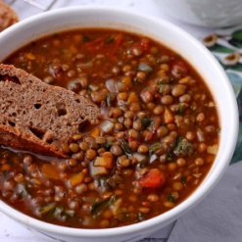
For a bonus (gratifica/incentivo), try to explain why you did or didn’t like it! For example:
The last thing I ate was a lentil soup. It was quite spicy, but a little bit mushy (molliccio), because I overcooked the lentils. I didn’t like it so much, because it was a little bland (insipido). Lentils don’t have much flavour (sapore/gusto).’
Now it’s your turn. Pause the video and make your answer.
Next, let’s see how you can talk about cooking habits.

Homework n 1
Watch the clip from (0.54) to (7.50)
Homework N2
Fill in the gaps using these words:
crumbly , tough, mushy, terrible, awful, amazing, crunchy, chewy, bland, tangy, sweet, junk, texture, spicy, flavour, bitter tender, sour, rich

- In the August 1998, while he was on holiday in Scotland, he dies because of a ……TERRIBLE………..…….. food intolerance.
- Beautiful place, ……………..…………. food and wine, very nice people.
- Real stream trout, the queen of fresh water, is an excellent fish with delicious, lean (without much fat/
thin) and never ………………….. meat.
- The meat is…………….…………., but tender and succulent in the best of ways.
- The food is of excellent quality with ……………………….. meat and not fat.
- Restaurant: My favorite restaurant is called La Poubelle, the French word for "trashcan,(bidone della spazzatura) " which is fitting because it actually serves ……………….……………… food.
- These bagels ( ciambelle di pane) are ……………….……………. rings of white bread
- If your cat always eats dry, …………………………… food, it's essential you provide ( fornisca) plenty of water
- During mastication the dry,………………..……….. or disintegrating ( frammentato) food turns into a soft, cohesive lump( grumo) , the "bolus".
- When your dog is suffering from Diarrhoea(/ˌdaɪəˈriːə/) , it is suggested to give them small amounts of ………..…………. food and to make sure they have plenty of fresh drinking water available at all times.
- This dessert is………………..
- What's happening is that( infatti) our kids are buying ……. ……………… food.
- He gets diarrhea when he eats …………………….……. food.
- You may also feel discomfort( disturbo) when consuming sweet or ……….…………….. food and drinks, or when you brush your teeth and rinse (si risciacquano) with cold water.
- Your palate will never forget the ………………………………. flavour of just-pressed olive oil.( olio nuovo)
- Children have an innate liking for sweetness, and a dislike for sour or …………………….……… foods
- Breakfast is a buffet of( a base di) ……………………….…… food, served in a hotel located nearby.
- These tablets( compresse9 have a delicious raspberrycherry( lampone)……………………………….
- Fermentation changes the taste and ……………………………… of foods, making them more interesting.

